**UNIT 1**

Scientists have been working on artificial intelligence since the middle of the last century. Their goal: To develop machines that learn and think like humans. Here is an overview of the key learnings and technological milestones they have reached.

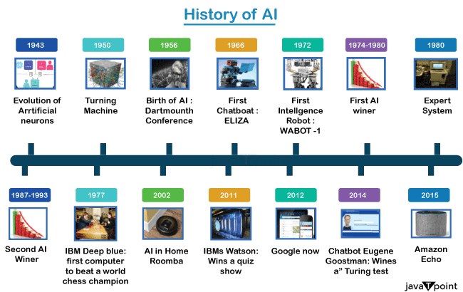

## 1936: Turing machine

## The British mathematician Alan Turing applies his theories to prove that a computing machine — known as a ‘Turing machine’ — would be capable of executing cognitive processes, provided they could be broken down into multiple, individual steps and represented by an algorithm. In doing so, he lays the foundation for what we call artificial intelligence today.

## 1966: Birth of the first chatbot

The German-American computer scientist Joseph Weizenbaum of the Massachusetts Institute of Technology invents a computer program that communicates with humans. ‘ELIZA’ uses scripts to simulate various conversation partners such as a psychotherapist. Weizenbaum is surprised at the simplicity of the means required for ELIZA to create the illusion of a human conversation partner.

## 1972: AI enters the medical field

With ‘MYCIN’, artificial intelligence finds its way into medical practices: The expert system developed by Ted Shortliffe at Stanford University is used for the treatment of illnesses. Expert systems are computer programs that bundle the knowledge for a specialist field using formulas, rules, and a knowledge database. They are used for diagnosis and treatment support in medicine.

## 1986: ‘NETtalk’ speaks

NETtalk is able to read words and pronounce them correctly, and can apply what it has learned to words it does not know. It is one of the early artificial neural networks — programs that are supplied with large datasets and are able to draw their own conclusions on this basis. Their structure and function are thereby similar to those of the human brain.

## 1997: Computer beats world chess champion

The AI chess computer ‘Deep Blue’ from IBM defeats the incumbent chess world champion Garry Kasparov in a tournament. This is considered a historic success in an area previously dominated by humans.

## 2011: AI enters everyday life

Technology leaps in the hardware and software fields pave the way for artificial intelligence to enter everyday life. Powerful processors and graphics cards in computers, smartphones, and tablets give regular consumers access to AI programs. Digital assistants in particular enjoy great popularity: Apple’s ‘Siri’ comes to the market in 2011, Microsoft introduces the ‘Cortana’ software in 2014, and Amazon presents Amazon Echo with the voice service ‘Alexa’ in 2015.

## 2011: AI ‘Watson’ wins quiz show

The computer program ‘Watson’ competes in a U.S. television quiz show in the form of an animated on-screen symbol and wins against the human players. In doing so, Watson proves that it understands natural language and is able to answer difficult questions quickly.

## 20xx: The near future is intelligent

It needs to become more reliable and secure against manipulation before it can be used in sensitive areas, such as autonomous driving or medicine. Another goal is for AI systems to learn to explain their decisions so that humans can comprehend them and better research how AI thinks.

**Some common AI applications include:**

* Virtual assistants like Siri and Alexa
* Recommendation systems used in e-commerce platforms
* Fraud detection in financial institutions
* Autonomous vehicles
* NLP for chatbots and customer service
* Image and facial recognition in security systems
* Medical diagnosis and healthcare systems

# **What is an AI Technique?**

Artificial Intelligence (AI) refers to developing computer systems for performing tasks requiring human intelligence. These systems assess large amounts of data to identify patterns and make logical decisions based on the collected information. The ultimate goal of AI is to create machines to carry out diverse tasks.

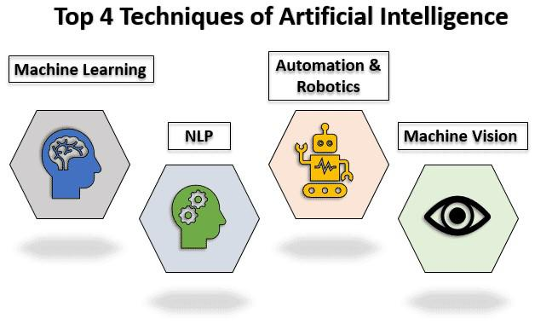

Artificial Intelligence techniques refer to a set of methods and algorithms used to develop intelligent systems that can perform tasks requiring human-like intelligence. Some of the widely used ones are:

* **Machine Learning.**
* **Natural Language Processing.**
* **Computer Vision.**
* **Deep Learning**
* **Robotics.**

## ****Machine Learning:****

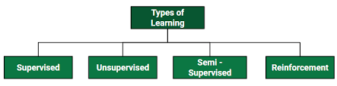

**1.** **Unsupervised machine learning** -AI systems analyse unlabelled data, where no predefined outcomes are provided. The objective is to uncover inherent structures or patterns within the data without any prior knowledge. For instance, it can group similar customer behaviour data to identify customer segments for targeted marketing strategies.

**2. Supervised learning** – A combination of an input data set and the intended output is inferred from the training data. AI systems learn from a labelled dataset, where each data point is associated with a known outcome. For instance, it enables email spam filters to distinguish between spam and legitimate emails based on learned patterns.

**3. Semi-supervised learning** – It is a method that uses a small amount of labelled data and a large amount of unlabelled data to train a model. The goal of semi-supervised learning is to learn a function that can accurately predict the output variable based on the input variables, similar to supervised learning. However, unlike supervised learning, the algorithm is trained on a dataset that contains both labelled and unlabelled data.

**4. Reinforcement learning** – In RL, the data is accumulated from machine learning systems that use a trial-and-error method to learn from outcomes and decide which action to take next. After each action, the algorithm receives feedback that helps it determine whether the choice it made was correct, neutral or incorrect. It performs actions with the aim of maximizing rewards, or in other words, it is learning by doing in order to achieve the best outcomes.

## ****Natural Language Processing:****

Natural Language Processing involves programming computers to process human languages to facilitate interactions between humans and computers.

However, the nature of human languages makes Natural Language Processing difficult because of the rules involved in passing information using natural language. NLP leverages algorithms to recognize and abstract the rules of natural languages, converting unstructured human language data into a computer-understandable format.

## ****Computer Vision:****

Computer Vision equips machines with the ability to interpret visual information from the world. This technique has revolutionized industries like healthcare, automotive, and robotics, enabling tasks such as facial recognition, object detection, and autonomous driving. The extent to which it can discriminate between objects is an essential component of machine vision.

**Sensitivity** in computer vision is an AI application’s ability to pick out small details in visual information. A low-sensitivity system may not pick up subtle clues in images or fail to work well in low lighting. However, high sensitivity might be able to look at an image’s fine details and pick up on information other systems might miss. A common example is Surveillance systems.

**Resolution** is the level of detail a computer vision system can capture and process. High-resolution images are vital for correctly identifying an image’s detail.

## ****Robotics & Automation****

Automation aims to enable machines to perform boring, repetitive jobs, increasing productivity and delivering more effective, efficient, and affordable results. To automate processes, many businesses employ machine learning, artificial neural, and graphs.

By leveraging the CAPTCHA technique, this automation can avoid fraud problems during online payments.

Robotic process automation is designed to carry out high-volume, repetitive jobs while being capable of adapting to changing conditions.

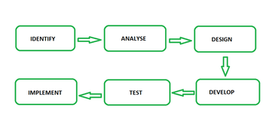

## ****Deep Learning:****

Deep learning is the branch of machine learning which is based on artificial neural network architecture. An artificial neural network or ANN uses layers of interconnected nodes called neurons that work together to process and learn from the input data.

**What is an Expert System?**

An expert system is a computer program that is designed to solve complex problems and to provide decision-making ability like a human expert. It performs this by extracting knowledge from its knowledge base using the reasoning and inference rules according to the user queries.

The performance of an expert system is based on the expert's knowledge stored in its knowledge base. The more knowledge stored in the KB, the more that system improves its performance. One of the common examples of an ES is a suggestion of spelling errors while typing in the Google search box.

Below is the block diagram that represents the working of an expert system.

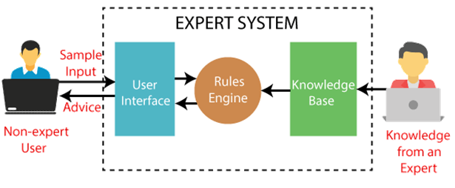

**Below are some popular examples of the Expert System:**

* **DENDRAL:** It was an artificial intelligence project that was made as a chemical analysis expert system. It was used in organic chemistry to detect unknown organic molecules with the help of their mass spectra and knowledge base of chemistry.
* **MYCIN:** It was one of the earliest backward chaining expert systems that was designed to find the bacteria causing infections like bacteraemia and meningitis. It was also used for the recommendation of antibiotics and the diagnosis of blood clotting diseases.
* **PXDES:** It is an expert system that is used to determine the type and level of lung cancer. To determine the disease, it takes a picture from the upper body, which looks like the shadow. This shadow identifies the type and degree of harm.
* **CaDeT:** The CaDet expert system is a diagnostic support system that can detect cancer at early stages.

**Components of an Expert System :**

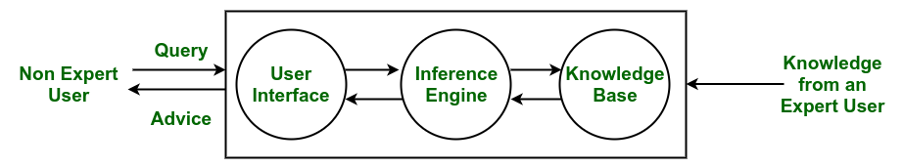

* **Knowledge Base –**  
  The knowledge base represents facts and rules. It consists of knowledge in a particular domain as well as rules to solve a problem, procedures and intrinsic data relevant to the domain.
* **Inference Engine –**  
  The function of the inference engine is to fetch the relevant knowledge from the knowledge base, interpret it and to find a solution relevant to the user’s problem. The inference engine acquires the rules from its knowledge base and applies them to the known facts to infer new facts. Inference engines can also include an explanation and debugging abilities.
* **Knowledge Acquisition and Learning Module –**  
  The function of this component is to allow the expert system to acquire more and more knowledge from various sources and store it in the knowledge base.
* **User Interface –**  
  This module makes it possible for a non-expert user to interact with the expert system and find a solution to the problem.
* **Explanation Module –**  
  This module helps the expert system to give the user an explanation about how the expert system reached a particular conclusion.

The Inference Engine generally uses two strategies for acquiring knowledge from the Knowledge Base, namely –

* Forward Chaining
* Backward Chaining

**Forward Chaining –**  
Forward Chaining is a strategic process used by the Expert System to answer the questions – What will happen next. This strategy is mostly used for managing tasks like creating a conclusion, result or effect. Example – prediction or share market movement status.

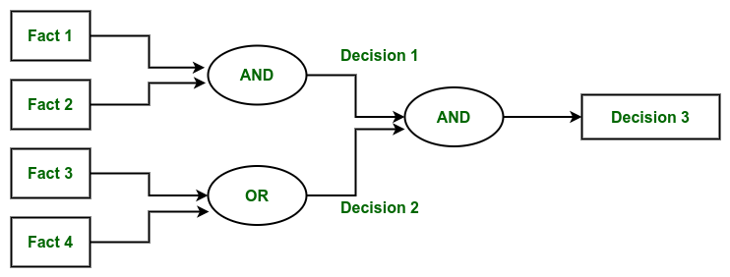

*Forward Chaining*

**Backward Chaining –**  
Backward Chaining is a strategy used by the Expert System to answer the questions – Why this has happened. This strategy is mostly used to find out the root cause or reason behind it, considering what has already happened. Example – diagnosis of stomach pain, blood cancer or dengue, etc.  

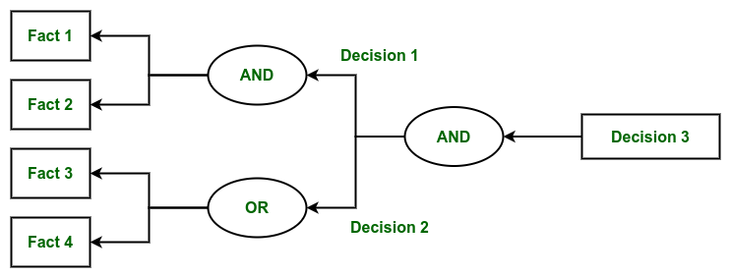

*Backward Chaining*

**Difference between Forwarding Chaining and Backward Chaining:**

|  | **Forward Chaining** | **Backward Chaining** |
| --- | --- | --- |

|  |  |  |
| --- | --- | --- |
| **1.** | **When based on available data a decision is taken then the process is called as Forward chaining.** | **Backward chaining starts from the goal and works backward to determine what facts must be asserted so that the goal can be achieved.** |
| **2.** | **Forward chaining is known as data-driven technique because we reaches to the goal using the available data.** | **Backward chaining is known as goal-driven technique because we start from the goal and reaches the initial state in order to extract the facts.** |
| **3.** | **It is a bottom-up approach.** | **It is a top-down approach.** |
| **4.** | **It applies the Breadth-First Strategy.** | **It applies the Depth-First Strategy.** |
| **5.** | **Its goal is to get the conclusion.** | **Its goal is to get the possible facts or the required data.** |
| **6.** | **Slow as it has to use all the rules.** | **Fast as it has to use only a few rules.** |
| **7.** | **It operates in forward direction i.e it works from initial state to final decision.** | **It operates in backward direction i.e it works from goal to reach initial state.** |
| **8.** | **Forward chaining is used for the planning, monitoring, control, and interpretation application.** | **It is used in automated inference engines, theorem proofs, proof assistants and other artificial intelligence applications.** |

**Characteristics of Expert System**

* **High Performance:** The expert system provides high performance for solving any type of complex problem of a specific domain with high efficiency and accuracy.
* **Understandable:** It responds in a way that can be easily understandable by the user. It can take input in human language and provides the output in the same way.
* **Reliable:** It is much reliable for generating an efficient and accurate output.
* **Highly responsive:** ES provides the result for any complex query within a very short period of time.

**Advantages :**

* Low accessibility cost.
* Fast response.
* Not affected by emotions, unlike humans.
* Low error rate.
* Capable of explaining how they reached a solution.

**Disadvantages :**

* The expert system has no emotions.
* Common sense is the main issue of the expert system.
* It is developed for a specific domain.
* It needs to be updated manually. It does not learn itself.
* Not capable to explain the logic behind the decision.

**Applications**

The application of an expert system can be found in almost all areas of business or government. They include areas such as –

* Different types of medical diagnosis like internal medicine, blood diseases and show on.
* Diagnosis of the complex electronic and electromechanical system.
* Diagnosis of a software development project.
* Planning experiment in biology, chemistry and molecular genetics.
* Forecasting crop damage.
* Diagnosis of the diesel-electric locomotive system.
* Identification of chemical compound structure.
* Scheduling of customer order, computer resources and various manufacturing task.
* Assessment of geologic structure from dip meter logs.
* Assessment of space structure through satellite and robot.
* The design of VLSI system.
* Teaching students specialize task.
* Assessment of log including civil case evaluation, product liability etc.

**What is an AI agent?**

An AI agent is a software that performs tasks on behalf of a user. They can automate processes, make decisions, and intelligently interact with their environment.

“AI agents are like magic,” said Patrick Hamelin, software engineer lead at Botpress. “They’re these magical entities that go beyond typical chatbots.”

AI agents are entities designed to perceive their environment and take actions in order to achieve specific goals. These agents can be software-based or physical entities.

They perceive their environment through sensors, process the information using algorithms or models, and then take actions using actuators or other means.

**What’s the difference between an AI agent and an AI chatbot?**

AI agents and chatbots differ in their purpose and capability. Chatbots are designed to interact with humans, while agents are designed to complete autonomous tasks.

The biggest difference is their ability to take autonomous actions. Since AI chatbots are designed for conversation with humans, they’re not usually programmed to take autonomous action – their purpose is to directly assist a human.

AI agents, on the other hand, may not interact with a user at all. In some cases, they’ll receive a task from a developer and follow through on it independently, without interacting with another human.

**How Intelligent Agent work Inside?**

An agent’s internal workings involve Agent program that run on computing device and process the data comes from the environment through its architecture. Let’s discuss how an agent works from the inside using program and architecture:

**Agent architecture**

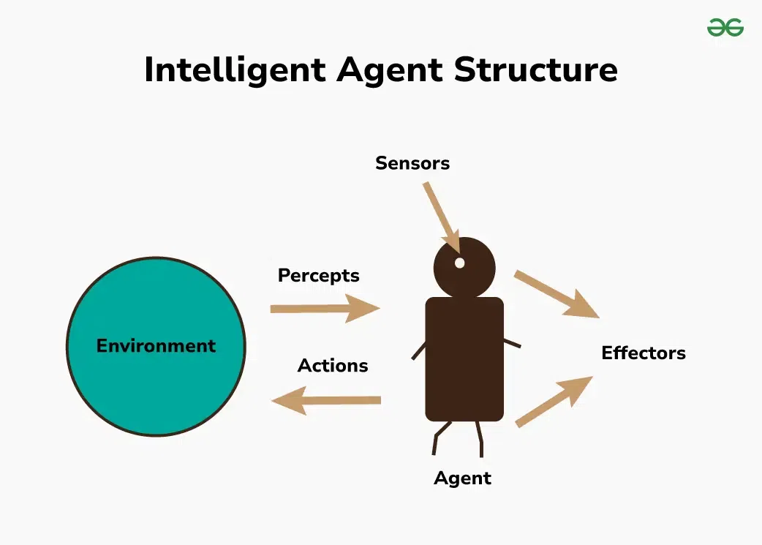

1. **Environment:**Environment is the area around the agent that it interacts with. An environment can be anything like a physical space, a room or a virtual space like a game world or the internet.
2. **Sensors:** Sensors are tools that AI agent uses to perceive their environment. They can be any physical like cameras, microphones, temperature sensors or a software sensor that read data from files.
3. **Actuators:**Actuators are tools that AI agent uses to interact with their environment through some actions. They can be any physical actuators like wheels, motors, robotic hands, or computer screens or they can be software actuators that send messages.
4. **Effectors:** Effectors take instructions from decision making mechanism and translates them into actions and these actions are performed through actuators.

## What is an Agent?

An agent can be anything that perceiveits environment through sensors and act upon that environment through actuators. An Agent runs in the cycle of **perceiving**, **thinking**, and **acting**. An agent can be:

* **Human-Agent:** A human agent has eyes, ears, and other organs which work for sensors and hand, legs, vocal tract work for actuators.
* **Robotic Agent:** A robotic agent can have cameras, infrared range finder, NLP for sensors and various motors for actuators.
* **Software Agent:** Software agent can have keystrokes, file contents as sensory input and act on those inputs and display output on the screen.

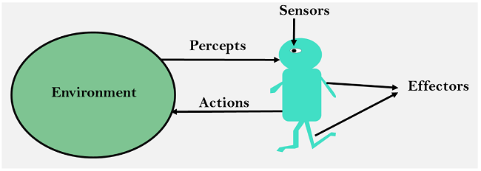

**Sensor:** Sensor is a device which detects the change in the environment and sends the information to other electronic devices. An agent observes its environment through sensors.

**Actuators:** Actuators are the component of machines that converts energy into motion. The actuators are only responsible for moving and controlling a system. An actuator can be an electric motor, gears, rails, etc.

**Effectors:** Effectors are the devices which affect the environment. Effectors can be legs, wheels, arms, fingers, wings, fins, and display screen.

Intelligent Agents:

An intelligent agent is an autonomous entity which act upon an environment using sensors and actuators for achieving goals. An intelligent agent may learn from the environment to achieve their goals. A thermostat is an example of an intelligent agent.

Following are the main four rules for an AI agent:

* **Rule 1:** An AI agent must have the ability to perceive the environment.
* **Rule 2:** The observation must be used to make decisions.
* **Rule 3:** Decision should result in an action.
* **Rule 4:** The action taken by an AI agent must be a rational action.

## Rational Agent:

A rational agent is an agent which has clear preference, models uncertainty, and acts in a way to maximize its performance measure with all possible actions.

A rational agent is said to perform the right things. AI is about creating rational agents to use for game theory and decision theory for various real-world scenarios.

**Intelligent Agent vs. Rational Agent**

|  |  |  |
| --- | --- | --- |
|  | **Intelligent Agent** | **Rational Agent** |
|  |  |  |
| **Definition** | **An**[**Intelligent Agent**](https://www.simplilearn.com/what-is-intelligent-agent-in-ai-types-function-article)**is a system that can perceive its environment and take actions to achieve a specific goal.** | **A Rational Agent is an Intelligent Agent that makes decisions based on logical reasoning and optimizes its behavior to achieve a specific goal.** |
| **Perception** | **An Intelligent Agent can perceive its environment through various sensors or inputs.** | **A Rational Agent's perception is based on the information available to it and logical reasoning.** |
| **Decision-making** | **It can make decisions based on a set of rules or a pre-defined algorithm.** | **It makes decisions based on logical reasoning and optimizes its behavior to achieve its goals.** |
| **Learning** | **An Intelligent Agent can learn from its environment and adapt its behavior.** | **A Rational Agent can also learn from its environment and adapt its behavior, but it does so based on logical reasoning.** |
| **Autonomy** | **It can operate independently of human intervention.** | **It can also operate independently of human intervention, but it does so based on logical reasoning.** |
| **Goals** | **An Intelligent Agent can be designed to achieve a specific goal.** | **A Rational Agent has a specific goal and optimizes its behavior.** |
| **Examples** | **An Intelligent Agent can be a self-driving car, a virtual personal assistant, or a recommendation system.** | **A Rational Agent can be a financial advisor, a chess-playing program, or a logistics planner.** |

**Applications of AI Agents**

AI agents have a wide array of applications – they’re beginning to make waves across numerous industries around the world. Here are a few of the most common:

**Customer Service**

Customer service chatbots are one of the most common types of AI agent deployment.

Because they can be plugged into company data, a business can use an AI agent to act as a customer assistant. They can provide access directly to the user’s device anywhere in the world, including a webpage via their computer or different apps (like WhatsApp or Facebook Messenger).



These chatbots and virtual agents can point customers towards specific policies, give them an idea of what items might fulfill their needs, or even provide access to their account by resetting a password.

It’s becoming expected for companies to offer customer service chatbots – most are powered by large language models and can complete specific tasks. The best ones are also able to take action on behalf of a business, like book a table or update a customer’s record.

**Autonomous Vehicles**

One of the flashiest uses of AI agents are self-driving cars and drones. These vehicles can operate with limited human input, thanks to the power of AI agents.

AI agents are integral to their functioning – they perceive the car’s environment and make informed decisions (like when it’s safe to turn or when to slow down). They can identify when the car is approaching a stop sign or explore a new type of terrain by accounting for environmental inputs.

**Virtual Assistants**

Agents like Siri, Alexa, and Google Assistant use AI to understand natural language, assist with tasks, provide information, and control smart devices.

**Turing Test in AI**

In 1950, Alan Turing introduced a test to check whether a machine can think like a human or not, this test is known as the Turing Test. In this test, Turing proposed that the computer can be said to be an intelligent if it can mimic human response under specific conditions**.**

Turing Test was introduced by Turing in his 1950 paper, "Computing Machinery and Intelligence," which considered the question, "Can Machine think?"

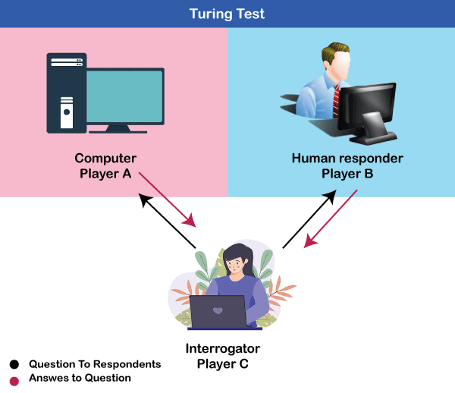

The Turing test is based on a party game "Imitation game," with some modifications. This game involves three players in which one player is Computer, another player is human responder, and the third player is a human Interrogator, who is isolated from other two players and his job is to find that which player is machine among two of them.

Consider, Player A is a computer, Player B is human, and Player C is an interrogator. Interrogator is aware that one of them is machine, but he needs to identify this on the basis of questions and their responses.

The conversation between all players is via keyboard and screen so the result would not depend on the machine's ability to convert words as speech.

The test result does not depend on each correct answer, but only how closely its responses like a human answer. The computer is permitted to do everything possible to force a wrong identification by the interrogator.

**Features required for a machine to pass the Turing test:**

* **Natural language processing:** NLP is required to communicate with Interrogator in general human language like English.
* **Knowledge representation:** To store and retrieve information during the test.
* **Automated reasoning:** To use the previously stored information for answering the questions.
* **Machine learning:** To adapt new changes and can detect generalized patterns.
* **Vision (For total Turing test):** To recognize the interrogator actions and other objects during a test.
* **Motor Control (For total Turing test):** To act upon objects if requested.

**Types of AI agents**

Based on their components, complexity, and real-world applications, here are the most common types of AI agents.

* Simple Reflex Agent
* Model-based reflex agent
* Goal-based agents
* Utility-based agent
* Learning agent

1. Simple Reflex agent:

* The Simple reflex agents are the simplest agents. These agents take decisions on the basis of the current percepts and ignore the rest of the percept history.
* These agents only succeed in the fully observable environment.
* The Simple reflex agent does not consider any part of percepts history during their decision and action process.
* The Simple reflex agent works on Condition-action rule, which means it maps the current state to action. Such as a Room Cleaner agent, it works only if there is dirt in the room.
* Problems for the simple reflex agent design approach:
  + They have very limited intelligence
  + They do not have knowledge of non-perceptual parts of the current state
  + Mostly too big to generate and to store.
  + Not adaptive to changes in the environment.

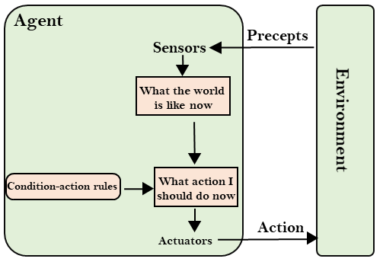

## 2. Model-based reflex agent

It works by finding a rule whose condition matches the current situation. A model-based agent can handle **partially observable environments** by the use of a model about the world.

The agent has to keep track of the **internal state** which is adjusted by each percept and that depends on the percept history. The current state is stored inside the agent which maintains some kind of structure describing the part of the world which cannot be seen.

Updating the state requires information about:

* How the world evolves independently from the agent?
* How do the agent’s actions affect the world?

## Model-Based Reflex Agents

## 3. Goal-based agents

These kinds of agents take decisions based on how far they are currently from their **goal**(description of desirable situations). Their every action is intended to reduce their distance from the goal. This allows the agent a way to choose among multiple possibilities, selecting the one which reaches a goal state. They usually require search and planning. The goal-based agent’s behavior can easily be changed.

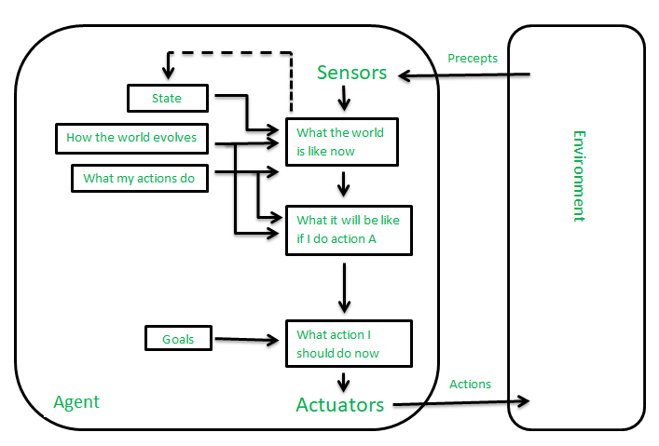

## 4. Utility-based agents

* These agents are similar to the goal-based agent but provide an extra component of utility measurement which makes them different by providing a measure of success at a given state.
* Utility-based agent act based not only goals but also the best way to achieve the goal.
* The Utility-based agent is useful when there are multiple possible alternatives, and an agent has to choose in order to perform the best action.
* Agent happiness should be taken into consideration. Utility describes how **“happy”** the agent is. Because of the uncertainty in the world, a utility agent chooses the action that maximizes the expected utility. A utility function maps a state onto a real number which describes the associated degree of happiness.

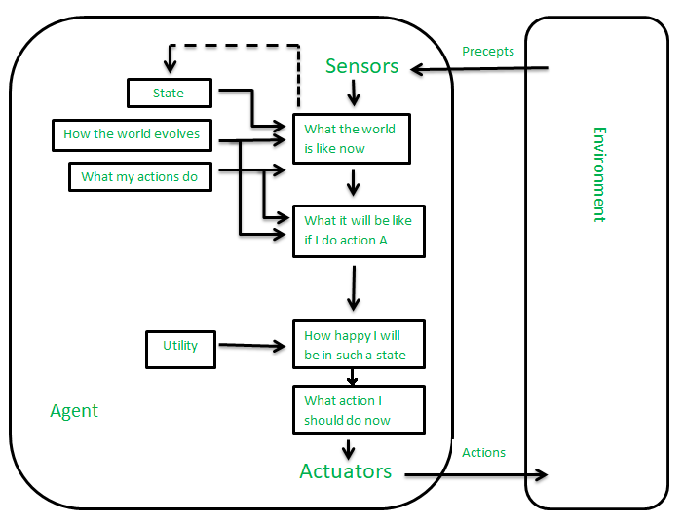

## 5. Learning Agents

A learning agent in AI is the type of agent that can learn from its past experiences or it has learning capabilities. It starts to act with basic knowledge and then is able to act and adapt automatically through learning. A learning agent has mainly four conceptual components, which are:

1. **Learning element:** It is responsible for making improvements by learning from the environment.
2. **Critic:**The learning element takes feedback from critics which describes how well the agent is doing with respect to a fixed performance standard.
3. **Performance element:** It is responsible for selecting external action.
4. **Problem Generator:** This component is responsible for suggesting actions that will lead to new and informative experiences.

